Backward Chaining
AIM:
To write a Prolog program to implement backward chaining and prove a goal using facts and rules.
ALGORITHMS:
- Start.
- Define facts in the knowledge base.
- Define rules that derive conclusions from existing facts.
- Accept a goal or query from the user.
- Check whether the goal matches a known fact.
- If the goal is not a fact, find a rule whose conclusion matches the goal.
- Check whether all conditions of that rule are satisfied by recursively proving its subgoals.
- If all subgoals succeed, declare the goal true; otherwise, try another applicable rule using backtracking.
- Display the result of the query.
- Stop.

CODE:
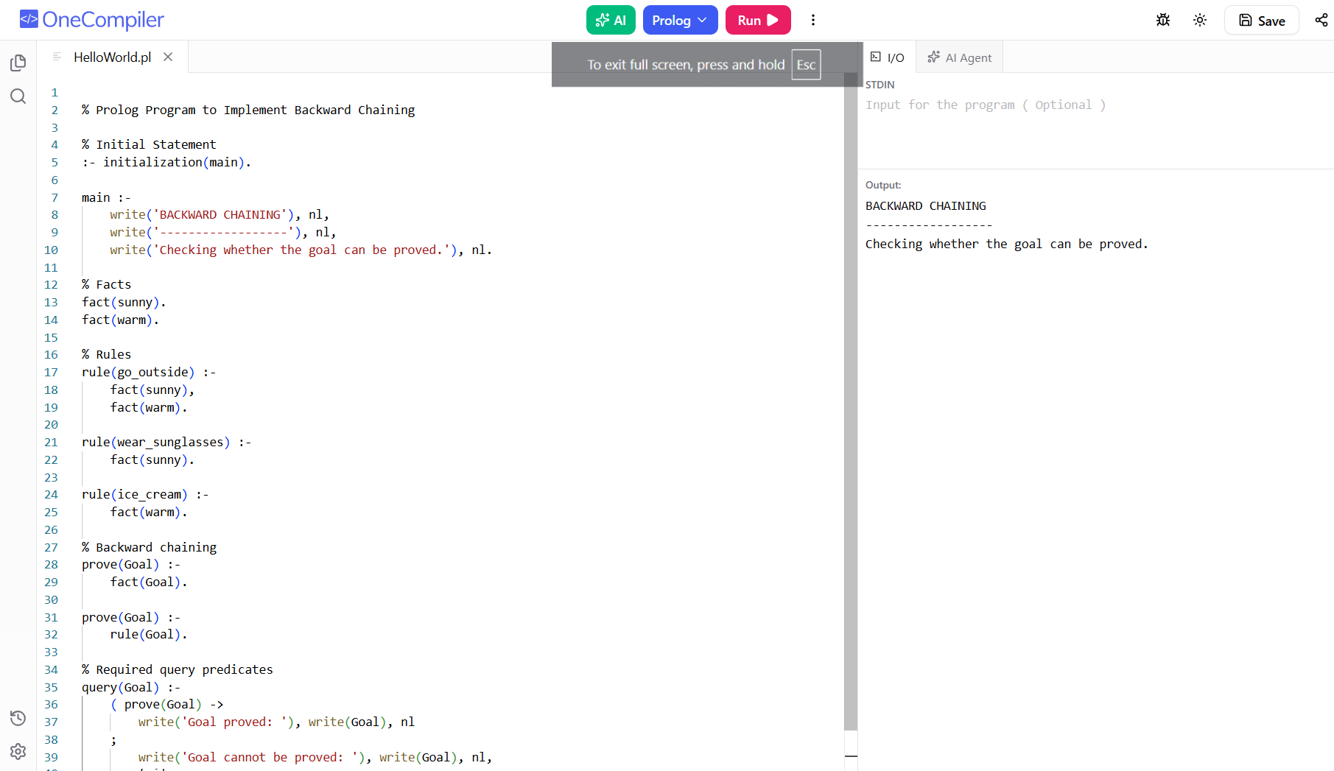

RESULTS:
The program determines whether a given goal can be proved using the available facts and rules.

